**Example: Mixing Drinks at Club Fever**

We are asked by Club Fever to come up with the optimal plan to mix drinks for a Thursday night. Excel file “Mixing Drinks.xlsx”

**Set up the Mixing Drinks model in Excel for Solver:**

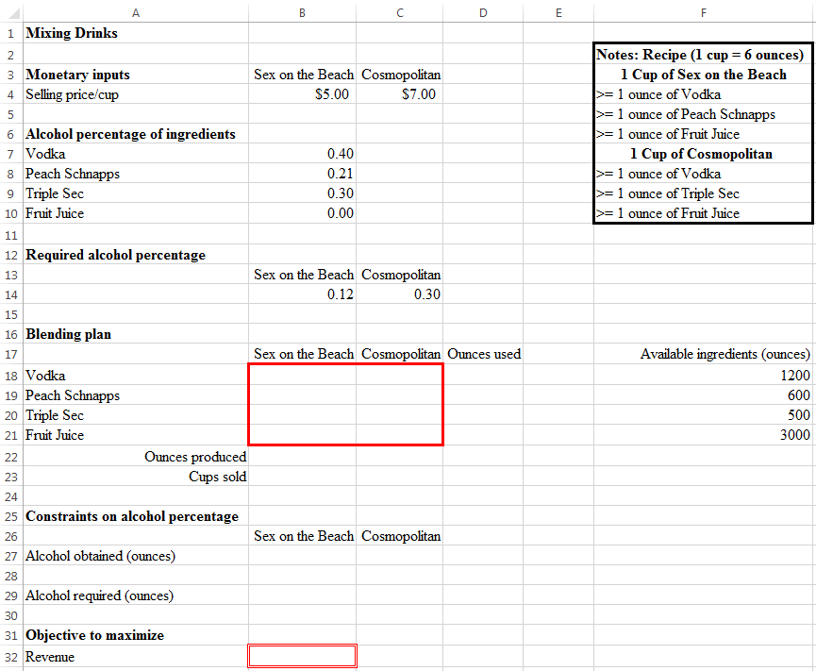

**Entering the Mixing Drinks model into Solver:**

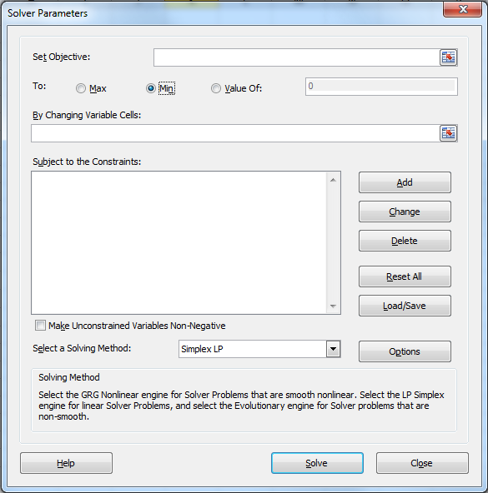

**Solution to the Mixing Drinks model:**

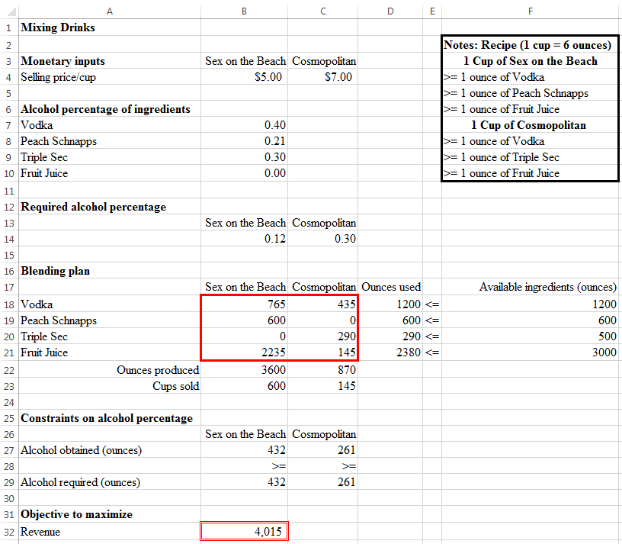

**Questions:**

1. With the above optimal mixing, Club Fever will obtain a revenue of $____________.

2. If Club Fever need to produce at least 200 cups of Cosmopolitan, how should we modify the model? How would the revenue change as a result of this modification?

3. Based on the original model, how much is Club Fever willing to pay for 2 additional handles (60 ounces each) of Peach Schnapps?